Q1 | Take the string 'Flipkart-Sale2024' and use string methods to convert it to lowercase, replace the dash with a space, and print the result.
Code | text = "Flipkart-Sale2024"  result = text.lower().replace("-", " ")  print(result)
Output | 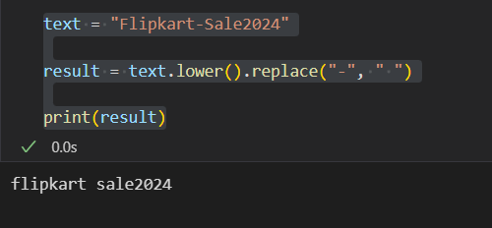

Q2 | Given the product name ' OnePlus Nord-CE 3 ', write code to clean it by removing extra spaces, converting all letters to uppercase, and replacing the dash with a colon.<br><br><em><strong>Hint:</strong> Use strip(), upper(), and replace() methods in sequence.</em>
Code | product_name = " OnePlus Nord-CE 3 "  clean_name = product_name.strip().upper().replace("-", ":")  print(clean_name)
Output | 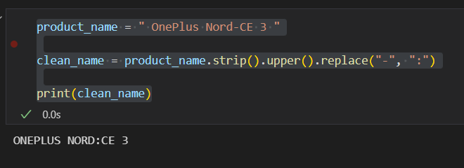

Q3 | Write a function split_product_code(product_code) that takes a string like 'ZOMATO-FOOD-2024' and returns a list of its parts using the split() method.
Code | def split_product_code(product_code):  return product_code.split("-")  product_code = "ZOMATO-FOOD-2024"  result = split_product_code(product_code)  print(result)
Output | 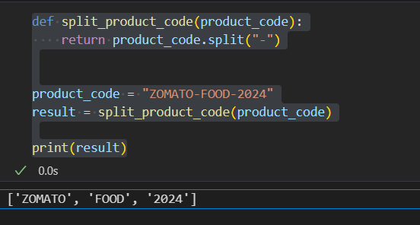

Q4 | Given the string 'Spotify_Premium_Offer', use string slicing to extract and print only the word 'Premium'.
Code | text = "Spotify_Premium_Offer"  word = text[8:15]  print(word)
Output | 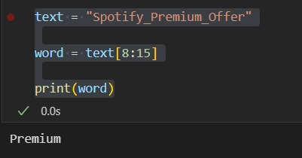

Q5 | Format and print a message using variables: product = 'Myntra Shirt', price = 799.5. The output should be: 'Deal: Myntra Shirt is available at ₹799.50 only!' using string formatting.
Code | product = "Myntra Shirt"  price = 799.5  print(f"Deal: {product} is available at ₹{price:.2f} only!")
Output | 